print

**Ideation phase**

Empathize & Discover

|  |  |
| --- | --- |
| Date | 17 OCTOBER 2022 |
| Team ID | PNT2022TMID40614 |
| Project Name | Rael- Time Communication System Powered by AI for Specially Abled |
| Maximum Marks | 4 Marks |

Empathy Map Canvas

Gain insight and understanding on solving customer problems.



Build empathy and keep your focus on the user by putting yourself in their shoes.

#import CountVectorizer

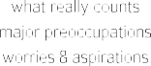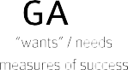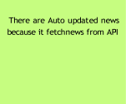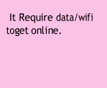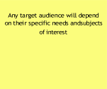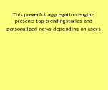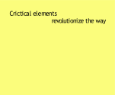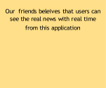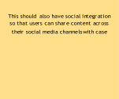

It track the latest

that has enabled

mobile apps to

users consume daily news

objectivity

Older audiences may not access

It acquires organic users in

manner

This application will show category wisenews

This will be

API and show itin the Application

The people

sites

from sklearn.feature_extraction.text import CountVectorizer #Document Input from the User

document = []

n = int(input("Enter the numer of lines in the document\n")) print("Enter the lines in the document")

for i in range(0,n) :

a = input() document.append(a)

…# Summarizing the Encoded Texts print("Encoded Document")

print

#import CountVectorizer

from sklearn.feature_extraction.text import CountVectorizer#Document Input from the User document = []

n = int(input("Enter the numer of lines in the document\n"))print("Enter the lines in the document") for i in range(0,n) :

a = input() document.append(a)

…# Summarizing the Encoded Textsprint("Encoded Document")